TASK 1:

Aim
To calculate the sum of similarities of a given string S with all of its suffixes.
Algorithm :
- Let the input string be S of length n.
- Create an integer array Z of size n.
- Initialize:
- Z[0] = n (entire string matches itself)
- left = 0, right = 0
- sum = n
- For each index i from 1 to n-1:
- If i <= right:
  - Set Z[i] = min(right - i + 1, Z[i - left])
- While characters match:
  - Compare S[Z[i]] with S[i + Z[i]]
  - Increment Z[i]
- If i + Z[i] - 1 > right:
  - Update left = i
  - Update right = i + Z[i] - 1
- Add Z[i] to sum
- Return sum
Program :
public static int stringSimilarity(String s) {
int n = s.length();
int[] z = new int[n];
int left = 0, right = 0;
int sum = n;
for (int i = 1; i < n; i++) {
if (i <= right) {
z[i] = Math.min(right - i + 1, z[i - left]);
}
while (i + z[i] < n && s.charAt(z[i]) == s.charAt(i + z[i])) {
z[i]++;
}
if (i + z[i] - 1 > right) {
left = i;
right = i + z[i] - 1;
}
sum += z[i];
}
return sum;
}
Output :
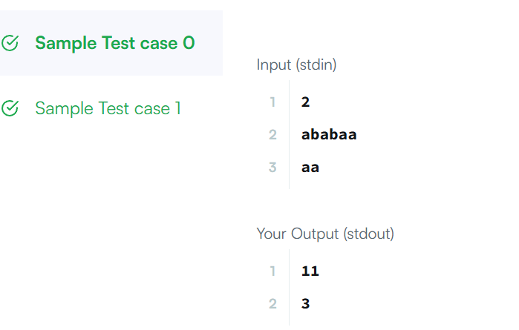

Result :
The program successfully calculates the sum of similarities of each given string with all of its suffixes using the Z-Algorithm technique and displays the correct total similarity value for each test case.
TASK 2

Aim :
To determine whether a given string can be formed by repeating one of its substrings multiple times.

Algorithm :
- Let the input string be s of length n.
- Concatenate the string with itself:
  - temp = s + s
- Remove the first and last characters from temp.
- Check whether the original string s exists inside this modified string.
- If it exists:
  - Return true (the string is made of repeated substring)
- Otherwise:
  - Return false
Program :
class Solution {
public boolean repeatedSubstringPattern(String s) {
String temp = s + s;
String modified = temp.substring(1, temp.length() - 1);
return modified.contains(s);
}
}

Output :
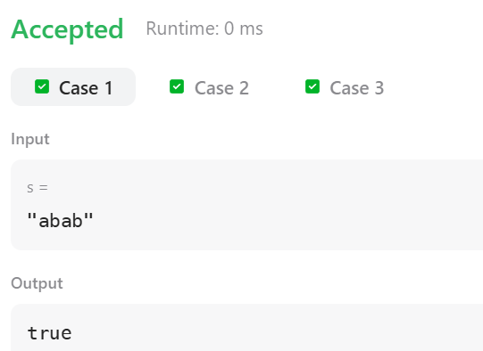

Result :
The program was executed successfully to the given string can be formed by repeating one of its substrings multiple times and displays true if it can be formed by repetition, otherwise displays false.

TASK 3

Aim :
To determine whether two given strings share at least one common substring.

Algorithm :
- Create a boolean array of size 26 (for lowercase letters a–z).
- Traverse the first string s1:
- Mark the corresponding character index as true.
- Traverse the second string s2:
- If any character is already marked true, return "YES".
- If no common character is found after checking all characters:
- Return "NO".
Program :
public static String twoStrings(String s1, String s2) {
boolean[] chars = new boolean[26];
for (char c : s1.toCharArray()) {
chars[c - 'a'] = true;
}
for (char c : s2.toCharArray()) {
if (chars[c - 'a']) {
return "YES";
}
}
return "NO";
}

Output :
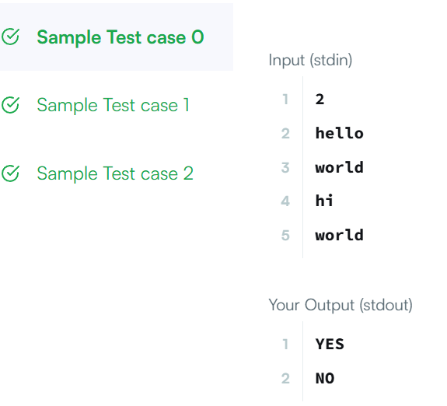

Result :
The program was executed successfully to the two given strings share at least one common substring and displays "YES" if they do, otherwise displays "NO".
TASK 4

Aim :
To determine whether a given string s can be transformed into another string goal by performing some number of left shifts.

Algorithm :
- If the lengths of s and goal are not equal:
- Return false.
- Concatenate string s with itself:
- temp = s + s
- Check if goal is a substring of temp.
- If yes:
- Return true.
- Otherwise:
- Return false
Program :
class Solution {
public boolean rotateString(String s, String goal) {
if (s.length() != goal.length()) {
return false;
}
String temp = s + s;
return temp.contains(goal);
}
}

Output :
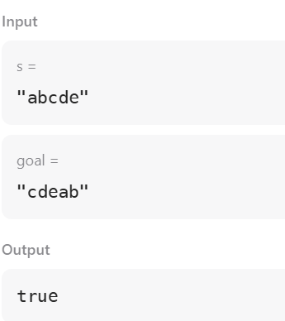

Result :
The program was executed successfully to the string s can be transformed into the string goal by performing some number of left shifts.

